|  |  |
| --- | --- |
| cetlogo ***CHEMICAL ENGINEERING TRANSACTIONS***  ***VOL. xxx, 2025*** | A publication of  aidiclogo_grande |
| The Italian Association  of Chemical Engineering  Online at www.cetjournal.it |
| Guest Editors: Bruno Fabiano, Valerio Cozzani  Copyright © 2025, AIDIC Servizi S.r.l. **ISBN** 979-12-81206-xx-y; **ISSN** 2283-9216 | |

Creating the 5th Edition of Lees’ Loss Prevention in the Process Industries – What is Lees 5, Why is it Important, and How to Overcome Editorial Challenges?

Hans Pasmana & Piet Knijffb

a TEES Mary Kay O'Connor Process Safety Center, Texas A&M University, College Station, Texas 77843, USA

bDiamantina Safety Consult, Born, the Netherlands

corresponding author: hjpasman@gmail.com

First created in 1980 by Prof. Frank P. Lees of Loughborough University, and later elaborated further by Prof Sam Mannan of Texas A&M University, the four successive editions of “Lees’ Loss Prevention in the Process Industries” have been recognized as The Process Safety Reference book, especially in the academic world.

Especially in recent years, Process Safety practitioners in the process industries however consulted Lees’ to a much lesser extent, as they found the scientific approach rather distinct from their daily challenges. Also, the international perspective was found underdeveloped.

Currently, we are experiencing a rapid technology transition (digitalization, decarbonisation, electrification). New developments in risk analysis can no longer mature in academia for years, they need to be applied in industrial practice much sooner than was the case in previous decades.

Prof. Faisal Khan of Texas A&M University concluded, therefore, that there is a need for a sound, international, state-of-the-art overview of Loss Prevention, connecting ‘daily’ industry applied practices and advanced academic knowledge, to serve as a reference for anyone active in this field. Just an update of the previous edition of Lees would not do, a completely new set-up was needed.

This ambition presents numerous challenges:

* How to appeal to both academia and industry?
* How to be relevant as a reference book and process safety handbook in this age of internet access to all kinds of (unfiltered) information?
* How to be comprehensive, i.e., address well-established methods as well as recently developed ones?
* How to interlink foundations and concepts, distributed over many process safety books and papers.
* How to ensure the international applicability of the methods described?
* How to appeal to both seniors as well as starters?
* And last but not least: How to find contributors who have the drive, expertise, and time to voluntarily reshape the legacies of Frank Lees and Sam Mannan?

Efforts to try and reconcile all the above aspects in the Lees’5th Ed. project will be described by Hans Pasman (academic perspective) and Piet Knijff (industrial perspective). The presenters may reach out to the audience as well: numerous contributors participate in the project already, but additional expertise is likely still to be required in order to complete this ambitious project. Therefore, if safety is your second nature and you have the drive, expertise, and time to help reshape this Process Safety Handbook, do not miss out on this presentation.

* 1. Introduction

In 1980, Frank P. Lees, (Loughborough University, UK), published Lees’ Loss Prevention in the Process Industries. After a period of growth and rapid developments in the process industry and in knowledge, and the occurrence of several major incidents showing the potential to cause harm, this first edition provided a comprehensive overview of the elements of loss prevention, with references to other publications substantiating or further detailing the knowledge presented.

In subsequent editions (see Figure 1), the original content was updated, and new content was added, to encompass the evolving knowledge of what became generally called ‘Process Safety’. Lees expanded to an encyclopedia-style book with numerous contributors and became known as the most complete single-source book on process safety. The latest (4th, 2012) edition presents a comprehensive review of nearly all aspects of process safety, with an extensive set of references to research papers.

Texas A&M / Mary Kay O’Connor Process Safety Center has started a project to produce the 5th edition of Lees’ Loss Prevention in the Process Industries (www.Lees5th.com). The Loss Prevention name has been kept, honoring Lees’ intent and tradition to bring the most comprehensive knowledge on process safety in one place. Why producing a 5th edition is important, what changes are needed, and the challenges to overcome is discussed in the next paragraphs.

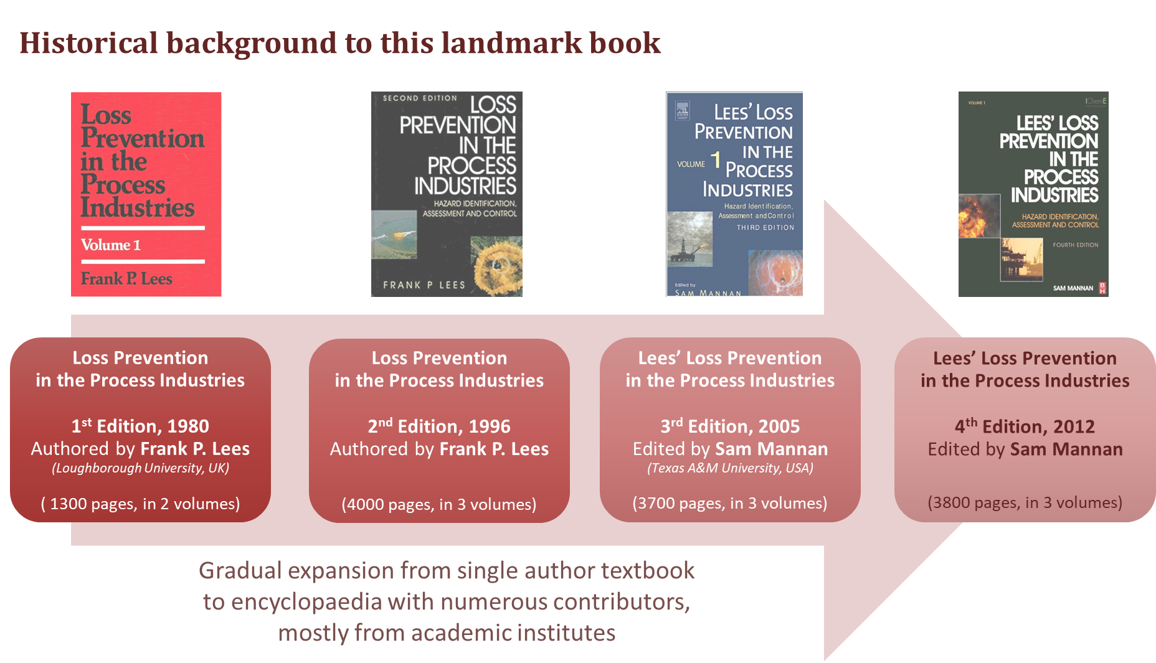

Figure 1: Overview of existing editions of Lees’ Loss Prevention in the Process Industries.

* 1. Why is having a Lees5th important?

Lees’ Loss Prevention is the recognized standard work providing the most complete collection of process safety theory, practices, and regulations in three volumes totaling about 3800 pages. Many other books on process safety are available, however, an entire library of such alternative books would be needed to approach the complete coverage of process safety that Lees’ Loss Prevention provides.

Maintaining the availability of such a renowned standard work might perhaps by itself be a reason to produce an updated fifth edition including the more recent developments. A closer examination of the purpose, strengths, and weaknesses of Lees’ demonstrates the full value of making a Lees 5th and also shows that in view of the rapid knowledge gain a full rewrite is required.

* + 1. The Importance of Process Safety

The importance and necessity of loss prevention are expanding during rapid technological transition. Abedsoltan et al. (2024) discuss future perspectives of process safety influenced by changes in the industrial landscape, emerging technologies, and evolving regulatory frameworks. Behie et al. (2023) discuss the challenges in process safety facing the industry and its senior leaders due to social/political/economic changes in the past few years, including dealing with the threat of climate change and making ongoing energy and digitalization adjustments.

Considering the significant developments since the fourth edition (2012), Lees5th will not be a review and update of previous editions, deleting obsolete methods and theories, but a total reorganization and update of contents, addressing also the process safety aspects of newer topics, for example:

* Increasing digitalization, e.g. real-time monitoring and barrier management, digital twins, data-driven decision-making, artificial intelligence, connectivity of devices, etc. Also, the various ways uncertainty can now be framed numerically or linguistically in different levels of information completeness.
* Expanded attention to physical and cybersecurity;
* Expanded attention to process safety aspects of offshore operations and forage and warehousing of hazardous materials, taking into account the follow-up of major incidents;
* (Emerging) process safety risks related to the energy transition, for example, Li-ion battery fires and explosions, battery energy storage, increased and different use of hydrogen, ammonia, and natural gas, wind turbines, CO2 capture, transport and storage, use of biofuels.

Catastrophic incidents may cause serious consequences for people, communities, the environment, and companies. Regulatory authorities will continue to fulfill their duty to create and maintain a framework that fosters and requires adequate attention to prevent major incidents. Public pressure on companies causing a process-related major incident is increasingly high and may ultimately result in losing the license-to-operate.

Lees5th needs to provide a sound, international state-of-the-art overview of Loss Prevention that will support anybody involved or interested in process safety in their role in ensuring the safety of their processes. It will serve the young generations to show the background and foundations of what may be hidden in current software based on experiments, accident learnings, and the theory of the 1970s and 1980s. And Lees5th may serve the older generation to see what today is conceptually possible and was not present in the previous century. AI and Bayesian networks were born many decades ago but came only available for process safety and risk management in this century.

* + 1. Target Audience

Especially in the academic world, consecutive editions of Lees’ Loss Prevention were seen and used as The Process Safety Reference book. Practitioners working in the process industries were less familiar with the latest editions of Lees and thus made less use of the wealth of knowledge in it. That may be due to the sheer volume and completeness of the information provided, discouraging those in need of practical solutions to urgent issues.

The intended audience for Lees5th is process safety practitioners or practitioners in training, engineers of all disciplines, operations, instrumentation and maintenance personnel, safety and environmental staff, students, researchers, and professors. It is designed for users with limited experience as well as for highly experienced professionals, for management with more, or less, technical background and people from other disciplines that make contributions to process safety such as human factors experts.

The global spreading of activities that include process safety risks is another factor to consider. Many good process safety practices can be and are applied wherever the activity takes place. The history and culture of the country or region do influence the legal environment as well as the company practices.

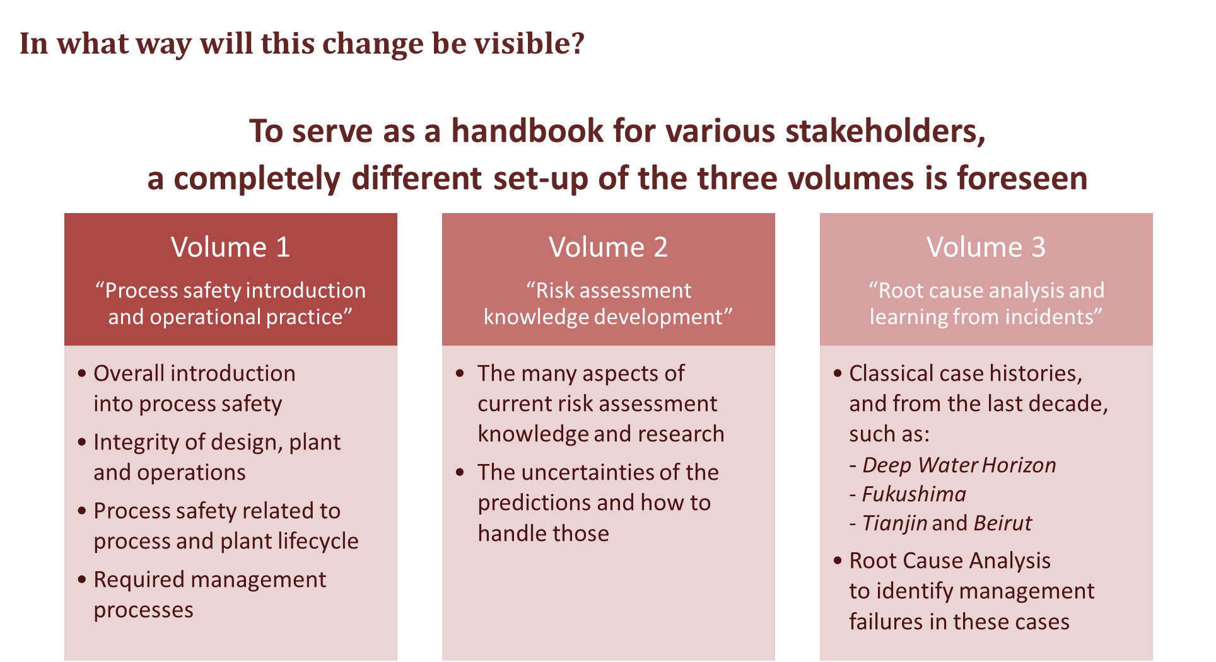

Figure 2: Set up of Lees5th in three Volumes.

Aiming at a global audience requires organizing the content and tailoring it, keeping the diversity of the needs of the target audience in mind. The set up of Lees5th will change to substantially improve the accessibility for all potential users. Lees5th is divided in three volumes (see Figure 2):

* Volume 1: process safety introduction and accepted operational practices, with links to content in Volume 2.
* Volume 2: risk assessment and knowledge development, providing academic background and knowledge that supports addressing more complex issues where the common practices in Volume 1 are encountering limitations.
* Volume 3: Root cause analysis and learning from experience, including the more recent case histories.

By selecting contributors from all over the world, the regional nuances in loss prevention practices will become visible and addressed where relevant and practical.

* + 1. Publishing Approach

Does it still make sense to publish all this knowledge in a (three-volume) book? How is it different from other process safety books? How is it going to make a difference? These are some of the frequently asked questions. Content, setup, and accessibility will demonstrate that there is a need for the hyperlinked fifth edition relating the various aspects and with references to the latest significant published contributions in the literature.

Timing of the Lees5th project and existing contractual agreements indicate that Lees5th will be published as a traditional book, and in an online version with functionality for search, downloading sections, figures, etc., providing links between the various topics and Volumes, giving relations between the concepts and approaches instead of describing isolated items. The Mary Kay O’Connor Process Safety Center and Elsevier will ensure user-oriented publishing and promotion.

* 1. Vision of Lees5th Edition

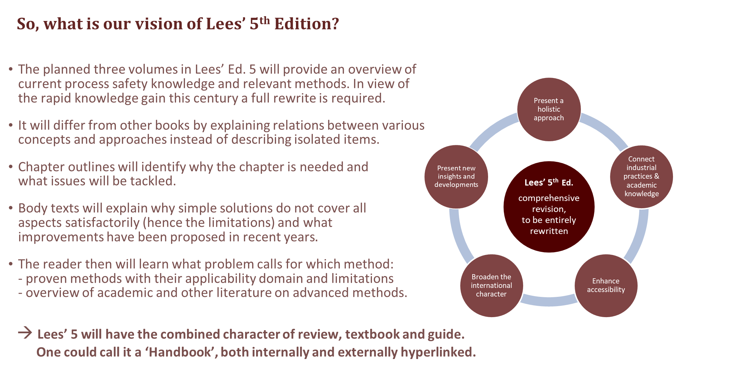

Figure 3: Vision of Lees 5th edition.

The considerations described in previous paragraphs resulted in a vision of Lees’ 5th edition that comprises the following elements (see also Figure 3):

* Provide a state-of-the-art overview of current process safety knowledge and methods.
* Broaden the international character, ensuring that relevant regional differences are recognized and addressed, serving global users.
* Develop a setup in three Volumes that connects proven and applied (industry) practices with academic knowledge and advanced methods for more complex issues and with the recent insights from learnings from experience.
* Not only treat the established knowledge and methods but also develop foresight on how to deal with process safety challenges entailed by the energy transition and decarbonization (Pasman et al., 2024), and by the collaborating robots (cobots) of Industry 5.0 leading to Safety 5.0 measures together with higher emphasis on sustainability and resilience (Pasman & Behie, 2024).
* Optimize accessibility for the different user groups, both through building up the content so that less experienced and experienced users find solutions for their questions and through online access functionalities.
  1. Challenges

Work on Lees5th was initiated early in 2022 by Michael O’Connor, who deceased in July 2022. The ideas further matured, and Hans Pasman is now leading the editorial team as chief editor. In Volumes 2 and 3, progress is being made although in certain areas contributions are still being sought. Making progress in Volume 1 proves to be more difficult, with the main reasons lying in:

* The need for experienced practitioners with industrial experience, able to write a compelling text on a certain topic, dominating that topic, and being able to reflect on state-of-the-art practices in various parts of the world (i.e., not only citing procedures and working methods from their own company). These people are hard to find and normally very busy.
* A willingness to share knowledge to the benefit of the process safety community. Most of the time formal permission of the employer is needed, which sometimes is difficult to obtain.
* A good distribution of contributors across the globe and with experience in different types of industries is needed to make Lees5th a true international handbook relevant to all potential users.
* It is all voluntary work. Even when committed to a contribution, higher-priority work may in practice interfere.

For main roles in the making of Lees5th, the process of finding contributors is still ongoing:

* Authors. Authors will write under their name and affiliation, which is mentioned directly below the main title of a chapter, just as in a published paper.
* Reviewers. To ensure the quality, all text will be peer-reviewed. A process standard to academic publications (with normally the reviewers remaining anonymous). This will also be applied to Volume 1 (sub-)chapters for which – upon mutual agreement – may be chosen to discuss certain improvement options or possible additions directly between author and reviewer (instead of via the editor). A reviewer from a different region or type of operation could add a broader perspective to a contribution. In such cases, reviewers’ names and affiliations will also be acknowledged.

A core group of knowledgeable editors will ensure a coherent setup of each volume, the relationships between the concepts and approaches in all volumes, and the relevance and quality of contributions.

Contributors are very welcome and ne eded now. The aim is to have Lees5th complete by the end of 2026. More information on the Lees5th project, how to contribute, and whom to contact can be found at the website [www.lees5th.com](http://www.lees5th.com)

* 1. Conclusions

Process safety knowledge is available in many books, papers, or online sources. These days, the essence is to guide assessing and sifting the available information. Building on the recognized and respected previous editions of Lees’ Loss Prevention in the Process Industries, the fully reorganized and rewritten fifth edition will serve as a reference for anyone active in this field. It will deliver a sound, peer-reviewed, international, state-of-the-art overview, connecting daily applied industry practices and advanced academic knowledge.

Rapid technology changes, energy transition, changes resulting from the drive to more sustainable processes and products, and changes in the business landscape, all increase the need for providing access to reliable process safety knowledge and methods. Loss prevention remains a qualifier for success. If you have significant experience in process safety, join us. There is still ample opportunity to contribute to this important project of preparing Lees’ Loss Prevention in the Process Industries, 5th edition.

References

Abedsoltan H., Abedsoltan A., Zoghi, Z., 2024, Future of process safety: Insights, approaches and potential developments, Process Safety and Environmental Protection, 185, 684-707. https://doi.org/10.1016/j.psep.2024.03.034.

Behie S.W., Pasman H.J., Khan F.I., Shell K., Alarfaj A., El-Kady A.H., Hernandez M., 2023, Leadership 4.0: The changing landscape of industry management in the smart digital era, Process Safety and Environmental Protection, 172, 317-328. https://doi.org/10.1016/j.psep.2023.02.014.

Pasman H., Sripaul E., Khan F., Fabiano B, 2023, Energy transition technology comes with new process safety challenges and risks. Process Safety and Environmental Protection 177, 765–794. https://doi.org/10.1016/j.psep.2023.07.036.

Pasman H. & Behie S.W., 2024, Safety 5.0: Safety Management Issues in Sustainable, Human-centric, and Resilient Industrial Systems, submitted to Journal of Safety and Sustainability.